

As-Built – Phase 1 Deployment

For:
Red Roof Inn

July 10, 2023
Version 1.0
Contents
1 Business Overview 6
1.1 Business Use Cases 6
1.2 Business Rules 7
1.2.1 Dynamic Greetings 7
1.2.2 Number Porting 7
1.3 Voicemail 7
1.4 Call Recording 8
1.5 Announce Estimated Wait Time (EWT) 8
1.6 Call back – Call Back in Queue 9
1.7 Call Back – No agents available 9
1.8 SMS Message 9
1.9 Agent Email 10
1.10 Reporting 11
2 Call Flows 12
2.1 Prompts and Messages 12
2.1.1 Configuration 12
2.2 Call Flow Diagrams 13
2.2.1 Main Greeting 13
2.2.2 GenRes Redicall-AA 14
2.2.3 GenRes Redicall-AA Cancel Reservation 15
2.2.4 GenRes – Call Entry 16
2.2.5 GenRes – Queue 17
2.2.6 Universal Customer Queue Treatment 18
2.2.7 GenRes – Spanish 19
2.2.8 GenRes – Spanish Customer Queue 20
2.2.9 GenRes - Escalations 21
2.2.10 Groups 22
2.2.11 Groups Escalation 23
2.2.12 Guest Relations 24
2.2.13 Guest Relations – Escalation 25
2.2.14 Content and Connectivity 26
2.2.15 FIT 27
2.2.16 RediRewards 28
2.2.17 Support 29
2.2.18 Disaster Management 30
2.2.19 Training 1 31
2.2.20 Training 2 32
2.2.21 Offer Callback Module 33
2.2.22 Voicemail 34
2.2.23 Call Back 35
3 Configuration 36
3.1 Queues 36
3.2 Routing Profiles 37
3.2.1 Common Settings 38
3.2.2 Routing Profile Definitions 38
3.3 Outbound Calling 41
3.4 Operational Parameters 43
3.4.1 Hours of Operation 43
3.4.2 Holidays 43
3.4.3 System Notification 43
3.5 Agent Status 43
3.6 Security Profile 44
3.7 Quick Connects 44
3.8 Agent Whisper 45
3.9 Agent Experience 45
3.10 Call Recording 46
3.11 System Configuration Settings 46
3.12 Lifecycle Policies 47
3.13 Kinesis / S3 Overview 48
3.14 SAML/SSO Configuration 49
4 Integrations 50
4.1 Red Roof Inn Lambda functions 50
4.2 New Lambda Functions 50
4.3 Databases 51
4.4 Admin Dashboard 53
4.4.1 General Block List 53
4.4.2 ITHD Block Numbers 53
4.4.3 Holidays 54
4.4.4 Prompts 55
4.4.5 Properties 55
4.4.6 AA Main 56
4.4.7 Mobile Routes 57
4.4.8 Services/DNIS 57
4.4.9 Services/Services 58

Version History
V1.2
SL No: | Version Number | Date Modified | Author | Comments
1 | V1.0 | Initial version | Scott Taylor / Allison Bicker | Initial Version
2 | V1.1 | 8/10/2023 | Scott Taylor | Updated existing call flo5/w diagrams; added new diagrams
3 | V1.2 | 9/25/2023 | Scott Taylor | Added Guest Relations Spanish updated call flow and related settings
4 | V2.0 | 5/7/2024 | Scott Taylor  Derek Yiu  Sidd Sankar  Allison Bicker | Updates made during Phase 3.

Table 1 – Version History

Business Overview

Business Use Cases
Red Roof Inn has identified the following functional requirements for the voice system implementation. The Amazon Connect Instance includes Contact flows for the following applications:
- General Reservations (Gen Res) (English & Spanish) and Escalations
  - The General Reservations team makes up the largest group of agents (approximately 200 by Summer 2023).
  - They handle inbound calls from 800 numbers and all US domestic numbers, no international calls.
  - They do not handle direct calls, no DIDs required.
  - Agents transfer to outside translators for other languages.
  - The Gen Res Escalations group handles escalations from both agents and direct external inbound calls. They also handle emails and calls for Disaster Management.
  - There are 136 TF numbers (13 are used for other skills, the rest are Gen Res).
  - 659 DIDs are assigned to individual hotels, they come into the same flow but the Hotel name is provided to the agent when a call is received
  - No voicemail options for Gen Res; voicemail is enabled for Nextline queue.
  - JAWS scripts applicable for agents
- Auto Attendant (AA) (referred to as RediCall AA script)
  - Additional skill for some Gen Res agents
  - JAWS scripts planned for agents
- RediRewards
  - Additional skill for some Gen Res agents
  - Separate 800 number for booking with RediRewards
  - Options include making a reservation (handled by Gen Res) and assistance with RediRewards accounts (handled by some Gen Res agents with this skill)
  - JAWS scripts applicable for agents
- Groups and Escalations
  - Both Groups and Groups Escalations handle Inbound and outbound calls, voicemail enabled
- Guest Relations
  - Inbound and Outbound calls
  - Emails and voicemails enabled
  - Guest Relations escalations team handles VP Customer care calls (high priority) as well as emails
- Content & Connectivity
  - Handle incoming calls, email communications
  - Voicemails enabled for this team
- FIT
  - Inbound and Outbound calls
  - No emails / voicemail enabled
- Support
  - Inbound calls
  - Voicemails enabled for this team
- Disaster Management
  - Inbound calls
  - No emails / voicemail enabled
  - Calls handled at highest priority

Business Rules

Dynamic Greetings
Text to Speech (TTS) will be utilized for dynamic greetings for each location. If WAV files are determined to be required, Red Roof Inn provided the files.

Number Porting
As part of the migration, configuration of new DIDs and TFNs will be completed.
- Up to 3,000 numbers will be ported
Coordination assistance for number porting processes will be provided. Red Roof Inn is responsible for managing communication with current carrier(s) and AWS.

Voicemail
Voicemail will be enabled on certain call flows required by Red Roof Inn. Voicemails consist of .wav files and transcripts of the recorded message. There is not an interface to retrieve voicemails in scope. Some of these groups do not have access to email in Outlook, instead a task is created with the attached .wav file and transcript and will be sent to the queue for review by the agents in each group.
The ability for a caller to playback their message or re-record a message will not be available in Phase 1.
Voicemail will be enabled for the following Queue/Skill groups, as referenced in List of Skills_Red Roof Inn_Revised_15MAY23.

Queue/Skill | Type | Routing Profile
Connectivity - VM | Voicemail | Connectivity
Content - VM | Voicemail | Content
Nextline - VM | Voicemail | GenRes Escalation
RFP VM | Voicemail | Groups
Groups -VM | Voicemail | Groups
Groups Escalation - V | Voicemail | Groups Escalation
Guest Relations - VM | Voicemail | Guest Relations
RRI Support VM | Voicemail | Support

Call Recording
All inbound and outbound calls will be recorded and stored in S3 along with call metadata. Recordings will be encrypted. A retention policy has been created to delete recordings after a specified period of time. See section 3.10 for more details.

Announce Estimated Wait Time (EWT)
Callers will be informed of their Estimated Wait Time (EWT) as a general time within one of three tiers:
- Less than 2 minutes
- Between 3 and 10 minutes
- Greater than 10 minutes
If the EWT is >= 2 minutes, the caller will be offered a call back option immediately or they can continue to hold.
After the caller has gone through a full cycle of hold messages, they will be offered the option to request a call back or remain in their position in queue. If applicable based on queue, the caller may also be offered the option to leave a voicemail.
The caller will confirm they would like to receive the call back from their caller ID or prompted to enter their 10-digit phone number, after 3 unsuccessful attempts they will be placed back in queue with no queued call back.

Call back – Call Back in Queue
When the caller requests a call back and they already have a call back in the queue, they will be informed that a call back is already scheduled, and the call will be disconnected. The call back will then occur when an agent is available.

Call Back – No agents available
If all agents are in an offline status for a specific queue, the caller will be prompted for a call back with no option to stay in queue. An email will be generated to alert Mangers that no agents are available.
Email message:
Included call time, skill, and ANI:
"You are receiving this auto-generated email because a call came in during operational hours and no agents were skilled.”
Email should be sent to:
- Shanna Wright – swright2@redroof.com
- Katie Henshaw – khenshaw@redroof.com
- Anitra Williams – amwilliams@redroof.com
- Janet Corder – jcorder@redroof.com
- Kelly Crump – kcrump@redroof.com
- Chris Gordon – cgordon@redroof.com

SMS Message
This section explains the process of sending SMS messages containing address, reservation, or cancellation details to customers using an AWS Lambda function integrated with Amazon Connect Contact Flows and Pinpoint.
The core component of this integration is an AWS Lambda function designed to send SMS messages.
The function retrieves necessary parameters such as the Pinpoint project (application) ID, the origination phone number (the sender's number), and the body of the message to be sent, along with the recipient's phone number. The AWS Lambda function is designed to be invoked by an Amazon Connect Contact Flow (For address RRI-IVR-Redicall-AAIVR).
The Contact Flow includes a step to invoke the AWS Lambda function, passing in detail such as the message content and the recipient's phone number as parameters.
Lambda Function Name: redroof-ivr-send-sms
It accepts two input parameters for operation:
messageToSend: The body of the SMS message intended for delivery.
sendToNumber: The recipient's phone number, essentially the customer's mobile number to which the SMS will be sent.

Given the absence of direct reservation and cancellation logic within our IVR, two contact flow modules have been developed to manage these functions. These modules are designed to be invoked immediately following the acquisition of a confirmation number for either a reservation or a cancellation. The following attributes must be configured:
For Cancellations: Set the attribute cancellationNumber with the relevant cancellation confirmation number.
For Reservations: set ReservationNumber to store the reservation confirmation number.

Below are the contact flow module names:
RRI-IVR-SendCancellationSMS
RRI-IVR-SendReservationSMS

Agent Email
Email to task functionality was implemented as an interim solution. Phase 2 includes a more robust SES solution.
When emails come into the mailboxes, they are forwarded appropriately to the team and a task is queued. Agents can then select the link in the task to open the email / Outlook webmail box. Once the email is handled, the task is closed. Tasks can be sent back to queue if they are rejected.
Current Emails Inbound/Outbound:
Queue/Skill | Type | Routing Profile | Email
Commission E-Mail - IB | Email | Connectivity | commission@redroof.com
RediPromise E-Mail - IB | Email | Content and Connectivity | redipromise@redroof.com
Disaster Management E-mail - IB | Disaster Email | Gen Res Escalation | disastermanagement@redroof.com
NextLine E-Mail - IB | Email | GenRes Escalation | nextline@redroof.com
SF Escalation E-Mail - IB | Email | GenRes Escalation | sfescalation@redroof.com
noreply-guestrelations - OB | Email | Guest Relation Escalation | noreply-guestrelations@redroof.com
RediRewards E-Mail - IB | Email | Guest Relations | reservations@redroof.com
Guest Relations E-Mail - IB | Email | Guest Relations | guestrelations@redroof.com
Guestin Email - IB | Email | Guest Relations | guestin@redroof.com
VP Customer Care | Email | Guest Relations Escalation | vpcustomercare@redroof.com
BBB Complaints | Email | Guest Relations Escalations | bbbcomplaints@redroof.com

Reporting
McIntosh supported Red Roof Inn with a reporting review and gap analysis.
- Reporting gap analysis and guidance
  - Identified critical data in existing reports and perform a gap analysis to ensure required data is present in reports from Amazon Connect
  - Proposed remediation activities for custom reporting or identify improvements to ETL process in the data pipeline.
  - Document the data pipeline, including ETL processes

Call Flows

Prompts and Messages

Configuration
All audio prompts and messages will be played using Connect’s text-to-speech facility. Prompts will be configured manually within the relevant blocks in the Connect call flows.
TTS prompt playback will be configured as follows:
- Language: English (en-US)
- Voice: Matthew
- Format: SSML
The exceptions to this will be the hold messages that are recorded by a “brand voice”. Those include the hold messages for Gen Res and HTS.

Call Flow Diagrams

Main Greeting

GenRes Redicall-AA

GenRes Redicall-AA Cancel Reservation

GenRes – Call Entry

GenRes – Queue

Universal Customer Queue Treatment

GenRes – Spanish
If no agents are available for Spanish Queue – an additional whisper will indicate it’s a failover from the Spanish queue.

GenRes – Spanish Customer Queue

GenRes - Escalations

Groups

Groups Escalation

Guest Relations

Guest Relations – Escalation

Content and Connectivity

FIT

RediRewards

Support

Disaster Management

Training 1

Training 2

Offer Callback Module

Voicemail

Call Back

Configuration

Queues
The following Queues were created based on Skills that existed in NICE. This table indicates whether the queue will receive Voicemails (Tasks) or Emails (Tasks).
Queue | Members | Tasks / Voicemail Enabled | Email Inbound / Outbound
AARP Members | Gen Res agents | No | No
GenRes | Gen Res agents | No | No
GenRes Click to Call | Gen Res agents | No | No
GenRes Online | Gen Res agents | No | No
Redicall-AA | Gen Res agents | No | No
GenRes RediCall | Gen Res agents | No | No
GenRes RediRewards | Gen Res agents | No | No
GenRes Mobile | Gen Res agents | No | No
GenRes_Spanish | Gen Res Spanish speaking agents | No | No
RediRewards Specialist | Gen Res RediRewards specialists | No | No
Disaster Management | Gen Res Escalation agents – Priority 1; Disaster management email | No | Yes
GenRes Escalation | Gen Res Escalations; SF Escalation email | Yes | Yes
Nextline | Gen Res Escalations; Nextline email | Yes | Yes
RFP Desk | Groups | Yes | No
Groups | Groups | Yes | No
Groups Escalation | Groups Escalation | Yes | No
Connectivity | Connectivity & RediPromise email | Yes | Yes
Commission | Commission | No | Yes
Content | Content; RediPromise email | Yes | Yes
FIT | FIT | No | No
Guest Relations | Guest Relations; RediRewards & Guest Relations & Guestin email | Yes | No
Guest Relations Spanish | Guest Relations Spanish agents | Yes | Yes
Guest Relations Escalation | Guest Relations Escalation | Yes | Yes
Support | Support | Yes | No
Training 1 | Training | No | No
Training 2 | Training | No | No
Extra Quick Connects | Extra Quick Connects – Queue not in Call Flows | No | No
Extra queue 1-4 | Allows for new queues will all Quick Connects | No | No
Quick Connects Main | All main quick connects – add to Routing profiles as needed | No | No

Routing Profiles
Routing Profiles are used to set up and control how incoming calls, chats, and emails are routed to specific agents. They allow contact centers to define the routing rules for each agent and the order in which they are applied. The configuration of Routing Profiles includes setting up routing rules and conditions, assigning skills, and setting up routing priority. This will be done as a joint effort between SoftwareOne and the Customer’s system admin(s).
Routing rules and conditions specify the criteria that must be met in order for a caller to be routed to a particular agent. Skills allow contact centers to associate agents with specific tasks. Routing priority determines the order in which agents are contacted when multiple agents are available.
Configuration options for Routing Profiles include setting the maximum number of conversations for each agent, setting up call forwarding rules, and configuring the routing language. Maximum conversation settings allow contact centers to limit the number of conversations an agent can handle at one time.

Common Settings
A routing profile will be configured for each team; all routing profiles will use the same settings apart from queue assignments, as noted below:
Enabled? | Channel | Max Contacts/Agent | Cross-Channel Concurrency
Yes | Voice | 1 | No other channels while agent is on Voice contact
No | Chat | 1 | No other channels while agent is on chat
Yes | Task | 1 | No other channels while agent is on task
All routing profiles will use “Outbound” as the default outbound queue.

Routing Profile Definitions
Please note – for voicemail to Task functionality, the Task Channel will be enabled on routing profiles where voicemail is enabled. For Local Measure email functionality, the Chat Channel will be enabled on routing profiles where email is enabled.
Name | Queues | Channels | Priority
Groups | Groups | Voice, Task | All Priority 1
RFP Desk | RFP Desk | Voice, Task | All Priority 1
Groups Escalation | Groups Escalation | Voice, Task | All Priority 1
Groups Escalation Alternate | Escalation +All Agent Queues | Voice | All Priority 1
Groups Hybrid | Groups and Groups Escalation Only | Voice | All Priority 1
Connectivity | Connectivity  Commission Email | Voice, Task, Chat | All Priority 1
Content | Content | Voice, Task | All Priority 1
Content – RediPromise | Content  RediPromise Email | Voice, Task, Chat | All Priority 1
Connectivity – RediPromise | Connectivity  RediPromise Email  Commission Email | Voice, Task, Chat | All Priority 1
Connectivity Phones Only | Connectivity Phones Only | Voice | All Priority 1
FIT | FIT | Voice | All Priority 1
Gen Res | AARP Member  GenRes  GenREs Click to Call  GenRes Online  Redicall-AA  GenRes RediCall  GenRes RediRewards  GenRes Mobile | Voice | GenRes Online, RediCall-AA and GenRes RediCalls– Priority 1  GenRes RediRewards – Prioriity 2  All Others – Priority 3
Gen Res Escalation | Disaster Management  Disaster Management Email  Route to RediResponse MFA  GenRes Escalation  Nextline  SF Escalation Email | Voice, Task, Chat | Priority 1  Priority 1  Priority 2  Priority 3  Priority 3  Priority 3
Gen Res Spanish | GenRes Spanish  AARP Member  GenRes  GenREs Click to Call  GenRes Online  Redicall-AA  GenRes RediCall  GenRes RediRewards  GenRes Mobile | Voice | GenRes Spanish – Priority 1  GenRes Online, RediCall-AA and GenRes RediCalls– Priority 2  GenRes RediRewards – Prioriity 3  All Others – Priority 4
Gen Res – RediRewards | RediRewards Specialist  AARP Member  GenRes  GenREs Click to Call  GenRes Online  Redicall-AA  GenRes RediCall  GenRes RediRewards  GenRes Mobile | Voice | GenRes Online, RediCall-AA and GenRes RediCalls– Priority 1  GenRes RediRewards – Prioriity 2  All Others – Priority 3
Gen Res – RediRewards - Spanish | RediRewards Specialist  AARP Member  GenRes  GenREs Click to Call  GenRes Online  Redicall-AA  GenRes RediCall  GenRes RediRewards  GenRes Mobile |  | GenRes Spanish – Priority 1  GenRes Online, RediCall-AA and GenRes RediCalls– Priority 2  GenRes RediRewards/RediRewards Specialist – Prioriity 3  All Others – Priority 4
Guest Relations | Guest Relations  l  Guest Relations Email  Guestin Email | Voice, Task, Chat | All Priority 1
Guest Relations Spanish | Guest Relations  Guest Relations Spanish | Voice, Task | All Priority 1
Guest Relations Escalation | Guest Relations Escalation  VP Customer Care Email  Guest Relations Escalation Email | Voice, Chat | Priority 2  Priority 1  Priority 2
Support | RRI Support | Voice, Task | All Priority 1
Training | Training 1  Training 2 | Voice | All Priority 1
RediResponse | RediResponse | Voice | All Priority 1
RediPromise Only | RediPromise Only | Voice, Task | All Priority 1
Training GenRes Escalation – Email only | Email Queues Only | Task | All Priority 1
Training Guest Relations Email | Emal Queues Only | Task | All Priority 1
Training RediRewards | ABAY RediRewards | Voice | All Priority 1

Outbound Calling
Agents will be enabled for outbound calling through Amazon Connect by assigning them to the “Outbound” queue. Outbound calling will be enabled as follows:
- Local, long-distance, and international calling will be enabled
- Local and long-distance calls must be prefixed with the US country code (1) and area code
- International calls must be prefixed with the country code
- Caller ID (note that outbound caller ID name is not supported by all carriers)

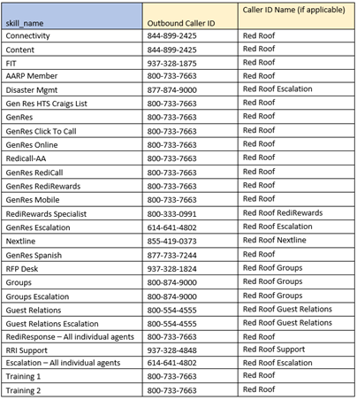

Operational Parameters

Hours of Operation
Each queue will have an operation schedule; the schedule will be configured with the hours of operation as shown in the table below. Calls arriving outside these hours will be greeted with an outside office hours message, if voicemail is configured, then an option to leave a voicemail will be offered.
See CX-RedRoofInn-Hours of Operation.xls

Holidays
The existing tenant Lambda function redroof-connect-holiday-checker will be used for the holiday schedule; the Lambda will also provide the message to be played back during holidays.
See CX-RedRoofInn-Hours of Operation.xls

System Notification
A system notification message can be configured to play as an initial message for all callers. The notification activation status and TTS message will be stored in a DynamoDB table and retrieved via a Lambda function.

Agent Status
Agent Status controls agents’ availability within the queue. Specific information about the reasons for an agent’s availability/unavailability can be indicated by creating additional status states.
'Available' is a system-default state which means that an agent is available and ready to take calls.
‘Offline’ is also a system-default state which indicates that an agent is not available to take calls.
Custom Agent Statuses will be configured:
- After Call Work
- Bio Break
- Break
- Call Backs
- Gen Res Escalation
- Lunch
- Meeting
- On Call ACW
- On Call Transfer
- Training
- Project
- Quality Coaching
- Training-Class/ABAY
- Training-Other

Security Profile
Amazon Connect includes default security profiles for general roles. The default configurations will be used for all profiles and SoftwareOne will assist admins with adjusting security profiles as needed for production.
The default security profiles are:
- Admin - An administrator can perform all actions available.
- Agent - An agent is a user of the system that is focused on customer care and/or sales. Their role is unlikely to be technical.
- CallCenterManager - A call center manager (or call center admin) manages the day-to-day aspects of the call center.
- Quality Analyst - A quality analyst works to improve the customer experience and keeps track of live service metrics.
Additional profiles added by Red Roof Inn:
- RTA - Used by RTAs - access to update Routing Profiles, real time metrics, historical metrics.
- Reporting – Reporting functions only.
- Supervisor – Supervisor and Senior Agents – ability to view users, view reporting, pull calls, live monitor

Quick Connects
Quick Connects is a feature in Amazon Connect that enables an agent to perform a transfer more quickly. Agents can utilize a quick list of options to transfer a call to an internal user, external number, or another queue. Quick Connects can be configured system-wide by an administrator or on an individual basis.
The following Quick Connects will be configured for initial production; additional Quick Connects may be configured on an as-needed basis.
The Red Roof Inn “Phone Book” of approximately 600 properties has been uploaded into Amazon Connect via API to populate the Quick Connects, as well as assign them to the appropriate queues (all queues will get the same phone book list).
Once the upload is completed, the maintenance and addition of Quick Connects will be manually managed by Red Roof Inn.
Due to the limitation of 700 Quick Connects per queue – we've created two queues that can be added to Routing Profiles for agents to see all relevant contacts:
- Quick Connects Main
- Extra Quick Connects

Agent Whisper

When an agent answers an incoming call or places an outbound call, Connect can deliver audio information prior to connecting the call.
Inbound: The property location of the inbound calling number will be identified in Whisper when the call is connected to the agent. This will be based on a look up of the incoming phone number.
Queue / Property ID / Property Name / Property ID
Outbound: When a call back is initiated to the Agent, a whisper will indicate that it’s Call back.
Database Lambda functions for this functionality will be provided by Red Roof Inn.

Agent Experience

The Connect Contact Control Panel (CCP) will be used as the call handling client.
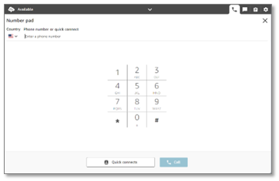
Figure 7 - CCP Screenshot
The CCP runs within a Web browser (officially Chrome) and allows the user to place and answer calls, toggle availability, select audio devices, and configure a forwarding number to send inbound calls to a mobile phone or other PSTN number.
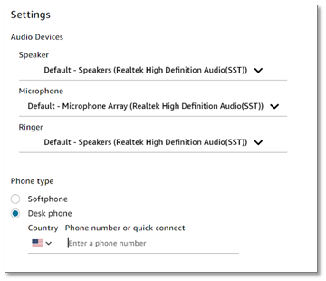
Figure 8 - Audio Configuration and Call Forwarding
For agents that will handle email, they will utilize the Local Measure front-end experience for voice, tasks and emails.

Call Recording
All calls (inbound and outbound) will be recorded and stored in S3 bucket redroof-cc-prod-ctr. Recordings will be encrypted using a key secured by KMS.
- Storage location: S3 bucket – redroof-cc-prod-ctr
- Encryption: enabled, key managed by KMS
- Retention policy: Retention for 6 months, then purge

System Configuration Settings
Item | Description | Policy Rule
Audio Recordings | Retention policy for audio recordings | 6 months
S3 Encryption | KMS Encryption
Kinesis Stream of CTR Data | CTR records will be streamed to an S3 bucket utilizing Kinesis Data Stream

Lifecycle Policies
The main S3 buckets for the Connect Deployment are:
- amazon-connect-148638fbc6fa - amazon-connect-148638fbc6fa - S3 bucket - this bucket contains call recordings, transcripts and reports for Connect
- redroof-cc-prod-ctr - redroof-cc-prod-ctr - S3 bucket (amazon.com) - this bucket contains the Contact Trace Records (CTR) for each call handled within Connect
The Lifecycle policies are as follows:
Day 0
- Objects uploaded
Day 89
- Objects moved to One Zone-IA
Day 180
- Objects expire
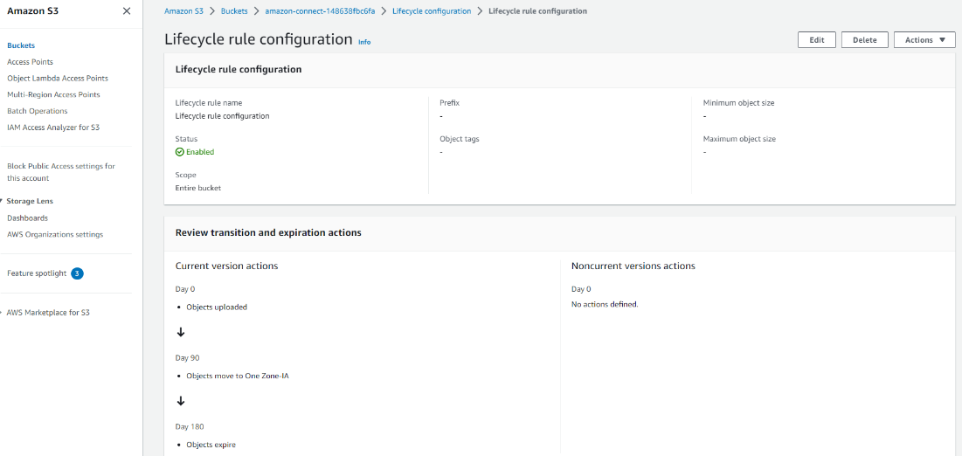

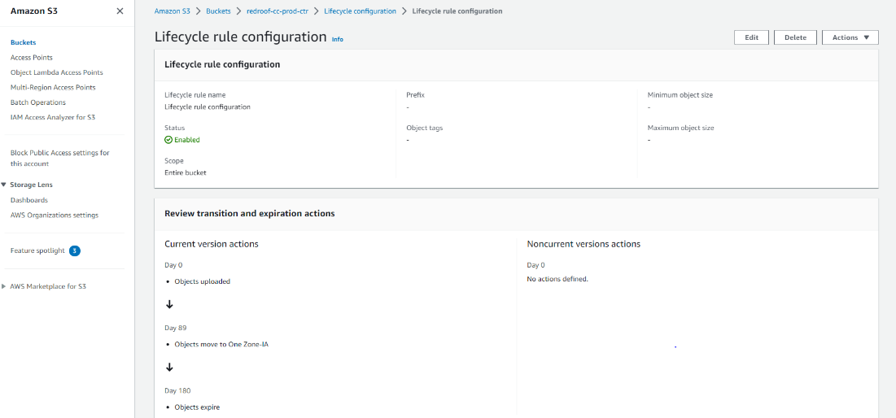

Kinesis / S3 Overview
Every call has a CTR record with all the call details. These records will be saved for every call for any future reporting needs.
Kinesis Data streaming has been configured to deliver the CTR call records to the redroof-cc-prod-ctr S3 bucket.

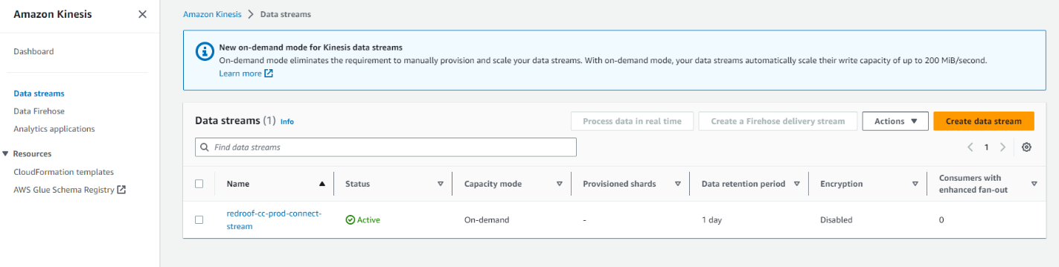

SAML/SSO Configuration
Agents that are Red Roof Inn employees will use Azure AD/Entra ID with their Red Roof Inn login credentials. Agents that are Ibex employees will use the Ibex ADFS URL to login.
There are two authentication parts in AWS:
- Amazon Connect CCP and Dashboard – this authentication uses the IAM IdP in AWS.
- Custom CCP – this uses both the above authentication along with Amazon Cognito.
Each of the above have a configuration for the specific Red Roof Inn and Ibex users.
Authentication | Red Roof Inn | Ibex
Amazon Connect | arn:aws:iam::123318811821:saml-provider/connect-aad-rri | arn:aws:iam::123318811821:saml-provider/adfs-ibex-sso
Custom CCP | arn:aws:cognito-idp:us-east-1:123318811821:userpool/us-east-1_kwMklDgi4  redroof-cc-prod-azure-idp-saml | arn:aws:cognito-idp:us-east-1:123318811821:userpool/us-east-1_GQEaJ4oTP  redroof-cc-prod-ibex-idp-saml
When updating the Metadata XML file, both the IAM IdP and the Amazon Cognito resources of the relevant organizations (Red Roof Inn or Ibex) must be updated, or the specific agents will not be able to login.
Red Roof Inn XML (for Cognito): https://login.microsoftonline.com/d1350479-b1e0-4f57-9375-03a40d7fba7e/federationmetadata/2007-06/federationmetadata.xml?appid=a00112e8-0777-4b93-be5c-5ed2a8c37457
Ibex Metadata XML: https://sso.ibexglobal.com/FederationMetadata/2007-06/FederationMetadata.xml
Changing the XML:
AWS IAM IdP:
- In Services > IAM, select Identity Providers
- Select the provider. Click Download Metadata to have a backup copy of the current XML metadata in use. (recommended in case of rollback). Then click Replace Metadata and select the new XML metadata.
Amazon Cognito:
- In Services > Amazon Cognito, select User Pools.
- Select the user pool. Select the Sign-in experience tab. In the Federated identity provider sign-in section, select the Identity provider (there should only be one per User pool)
- In the Metadata document section, click Replace metadata and enter the new metadata URL or file.

Integrations

Red Roof Inn Lambda functions
These functions have been created by Red Roof and made available for integration with the Connect implementation.
- aws-connect-transfer_number_lookup
- aws-connect-phone_number_lookup
- aws-connect-blocked_number_lookup
- aws-connect-aa_main_lookup
- aws-connect-pause_resume_recording
- aws-connect-agent_lookup

New Lambda Functions
The following Lambda functions were created to support this design by Red Roof Inn and SoftwareONE.
- redroof-connect-holiday-checker – verifies Holidays; called by appropriate Call flows
- redroof-connect-rollout-checker – checks for emergencies; called by appropriate Call flows.
- redroof-connect-get-next-prompt - A simple mobile backend (read from DynamoDB).
- redroof-connect-cancel-reservation - Invokes an RRI-provided Web service to cancel a reservation. Takes the confirmation number as input.
- redroof-ivr-email-to-task – Converts an e-mail forwarded by SES to a task with a link to the email in Exchange Online.
- redroof-ivr-email-to-manager – Sends alert e-mail to one or more SMTP addresses in the event of a queue out-of-service situation (all agents logged out).
- redroof-ivr-get-service-config – Gets the service-specific call treatment configuration for a given DNIS. Returned information includes service-specific messages for closure, holidays, and weather outages, brand (if applicable), queue ID and name, call flow to invoke (for dynamic routing), voicemail enabled/disabled (and custom voicemail message if needed), and whether the number is used for transfer in from a property.
- redroof-ivr-readcallback – Searches the redroof-connect-callback table for an entry matching the given callback number.
- redroof-ivr-writecallback – Writes a callback request to the redroof-connect-callback table for later use when checking to see if a callback request has been placed.
- redroof-ivr-removecallback – Removes the callback request from the redroof-connect-callback table.
- redroof-ivr-get-callback-hours – Retrieves the configured allowed callback hours for the given queue from the redroof-ivr-callback-check table
- redroof-ivr-check-callback-hours – Checks to see if the current time is within the configured allowed callback hours for the queue.
- redroof-route-to-agent – Maps a phone number (DID) to a Connect agent ID. Used for direct-to-agent calling.
- redroof-map-contact-to-agent – Updates the redroof-map-contact-to-agent table with the given contactId. Used to provide a contact ID for recording pause/resume from Red Roof’s external agent application.
- rr-vm-kvsConsumerTrigger - AWS Lambda Function to start (asynchronous) streaming transcription; it is expected to be called by the Amazon Connect Contact Flow. This function is part of the voicemail subsystem.
- rr-vm-processContactSummary - AWS Lambda Function that will be triggered when the wav call recording file is placed in S3. This function will collect all the transcript segments, and the audio file location and update the contact database. This function is part of the voicemail subsystem.
- rr-vm-kvsTranscriber - Process audio from Kinesis Video Stream and use Amazon Transcribe to get text for the caller audio. Will be invoked by the kvsConsumerTrigger Lambda, writes results to the transcript DynamoDB tables, and uploads the audio file to S3. This function is part of the voicemail subsystem.

Databases
The following DynamoDB tables are utilized in the deployment:

- aws-connect-aa_main
- aws-connect-blocked-number
- aws-connect-blocked-number-ITHD
- aws-connect-mobile_route
- aws_connect_phone_mapping
- redroof-cc-prod-ses-agent-tracking (Email solution)
- redroof-cc-prod-ses-email-table (Email solution)
- redroof-cc-prod-ses-inbound-mailbox-tracking (Email solution)
- redroof-cc-prod-ses-property-information (Email solution)
- redroof-cc-prod-ses-property-information-dev (Email solution)
- redroof-cc-prod-ses-spam-tracking (Email solution)
- redroof-connect-callback
- redroof-connect-holiday
- redroof-connect-prompts
- redroof-connect-rollout
- redroof-connect-subsource-map (CCP Subsource mapping)
- redroof-ivr-callback-check
- redroof-ivr-dnis-map
- redroof-ivr-serviceconfig
- redroof-map-contact-to-agent
- redroof-route-to-agent
- redroof-ses-missed (Email solution)
- rr-vm-contactDetails
- rr-vm-contactTranscriptSegments

Admin Dashboard
The following is an overview of the Admin Dashboard - Red Roof Inn Softphone. Admin Security profiles have access to this dashboard once logged in with SSO credentials. Each link in the dashboard corresponds with the DynamoDB database and adds/updates/deletions update the databases.

General Block List
To add numbers to the General Blocked Calls List (DynamoDB: aws-connect-blocked_number)
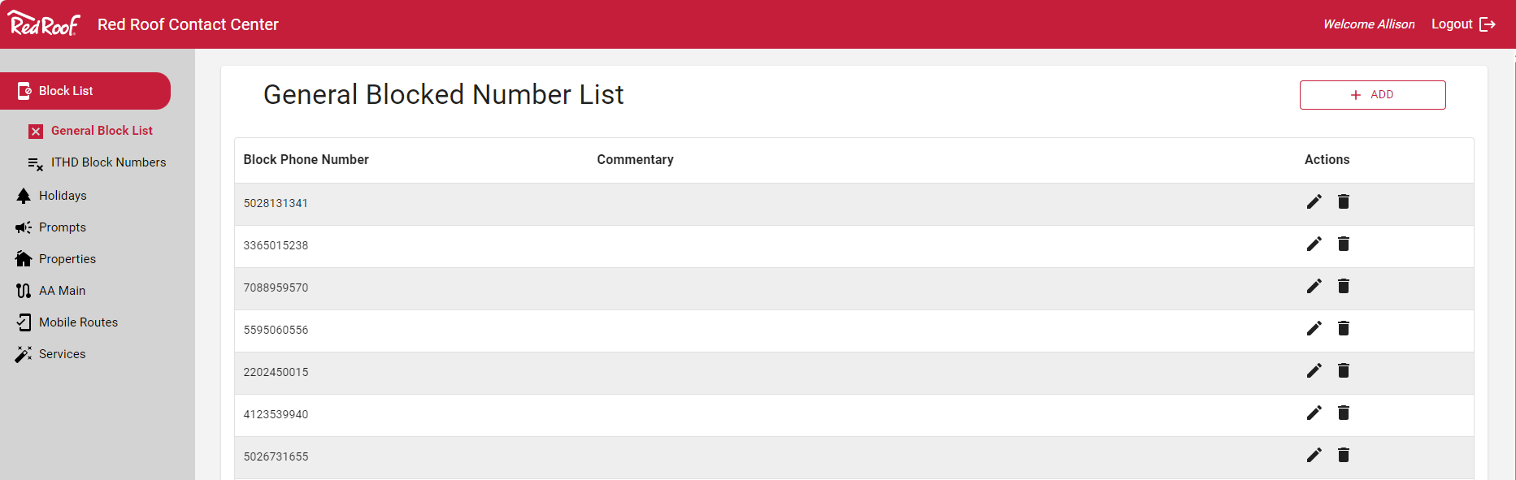
Click the +Add button to add a new entry.
Click the pencil icon to edit an existing entry.
Click the delete icon to delete and existing entry.
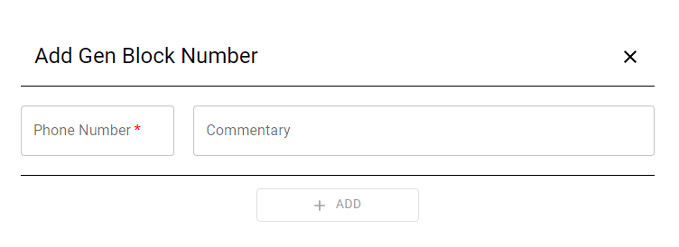
To add a Block Number, enter the phone number, commentary (optional) and click +Add).

ITHD Block Numbers

To add numbers to the ITHD Blocked Calls List (aws-connect-blocked_number-ITHD):
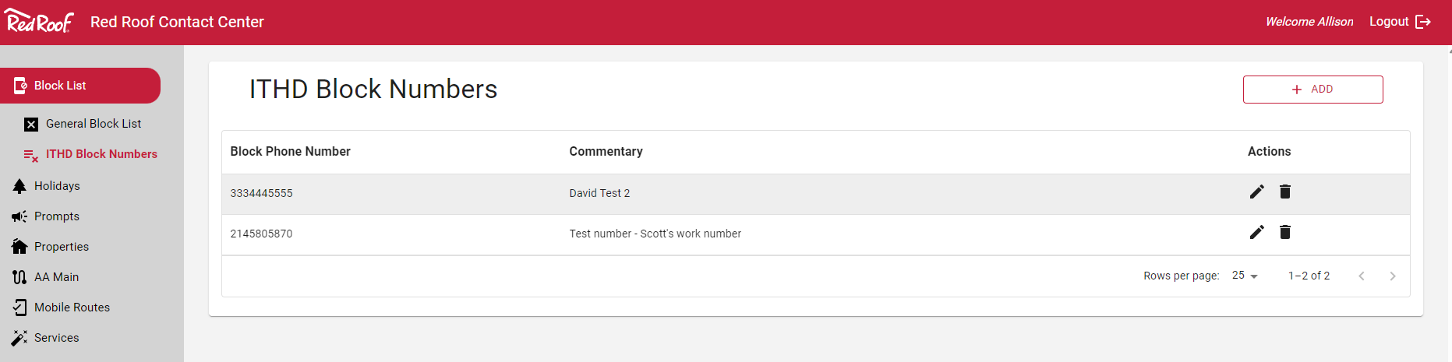
Click the +Add button to add a new entry.
Click the pencil icon to edit an existing entry.
Click the delete icon to delete and existing entry.
To add a Block Number, enter the phone number, commentary (optional) and click +Add).

Holidays
Add, update or edit redroof-connect-holiday database. These holidays are honored by the Call Flows.
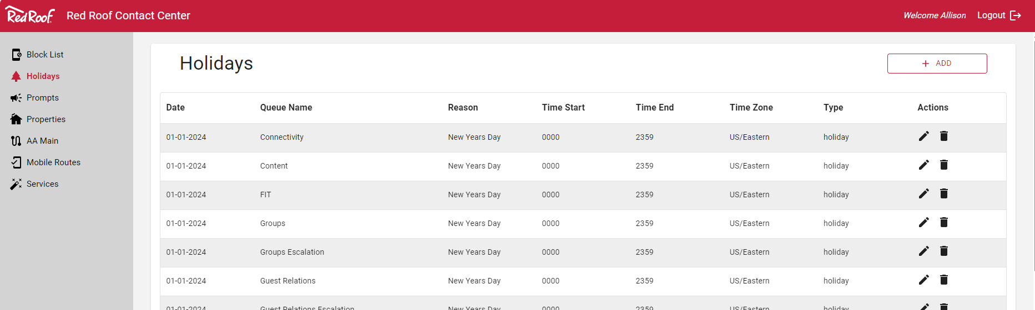

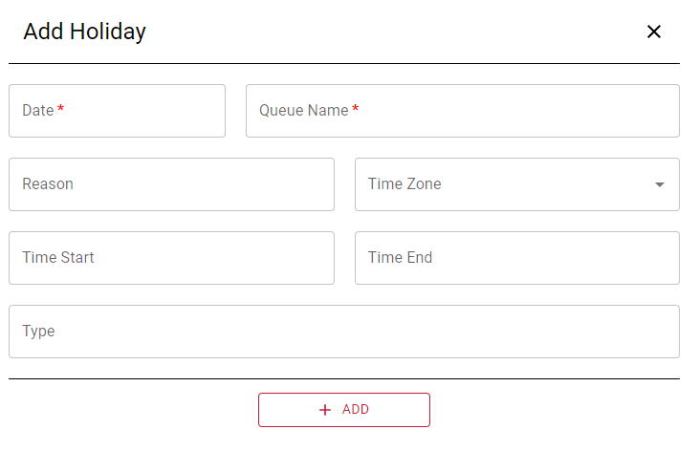

Prompts
Add, update or edit redroof-connect-prompts database. This allows for editing of prompts in the Call Flows. New prompts will need to be integrated into existing Call Flows (additional steps required).

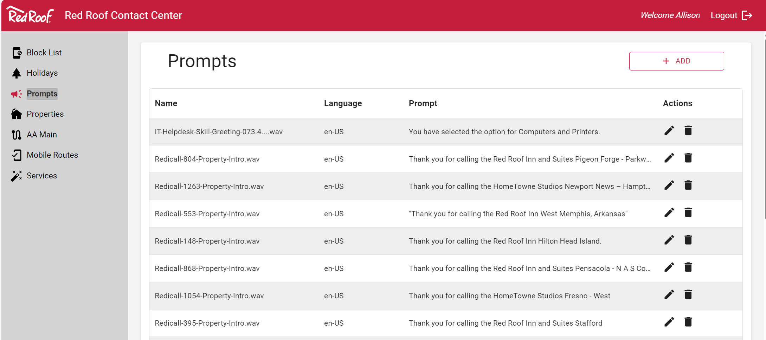

Properties
Add, update or edit redroof-cc-prod-ses-property-information database. This property information is displayed in the CCP Email solution.

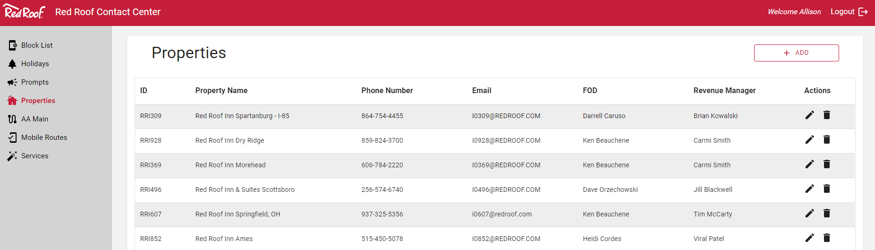

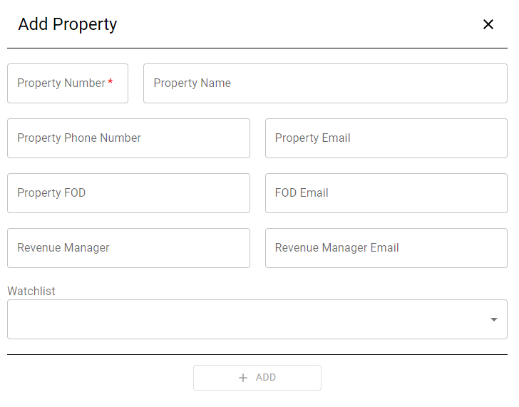

AA Main
Add, update or edit aws-connect-aa_main database. This maps property locations and front desk numbers.

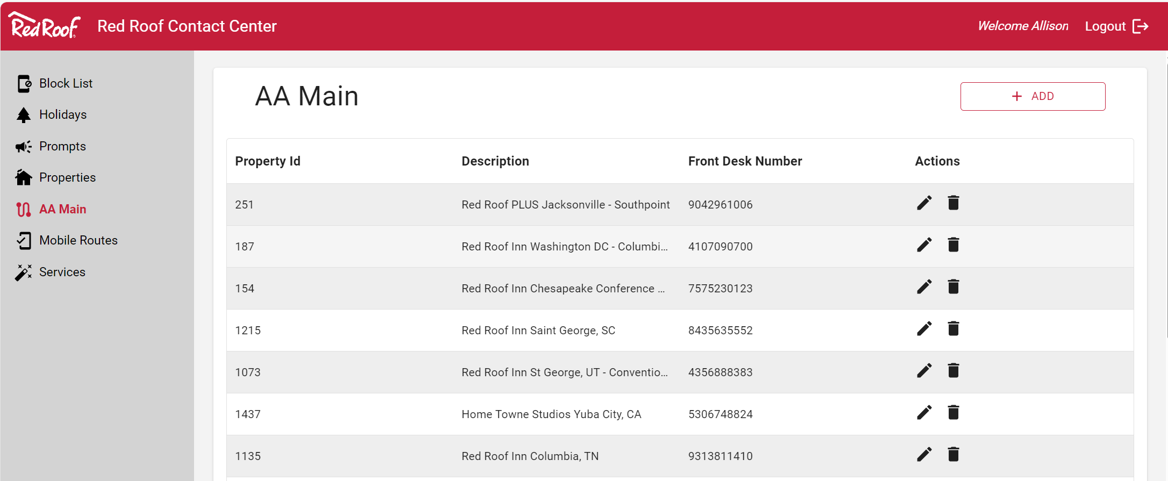

Mobile Routes
Add, update or edit aws-connect-mobile_route database. This maps mobile numbers to properties.

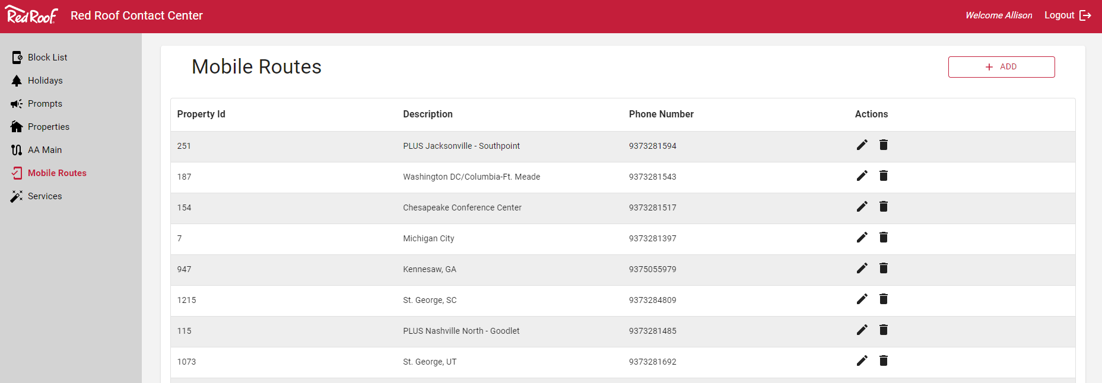

Services/DNIS
Add, update or edit redroof-ivr-dnis-map database. This maps incoming numbers to specific queues.
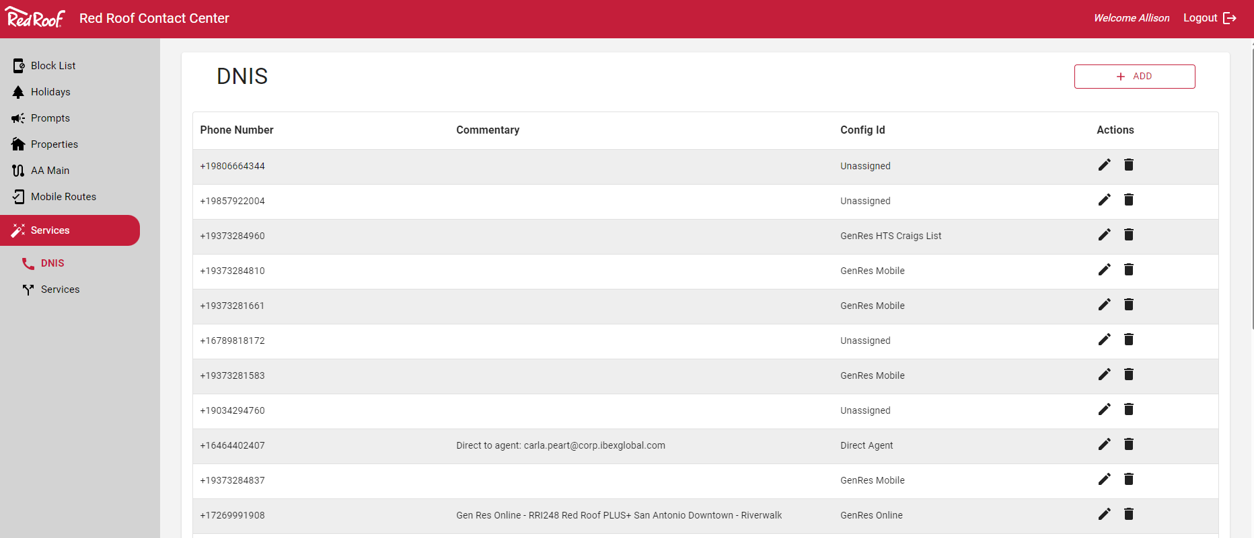

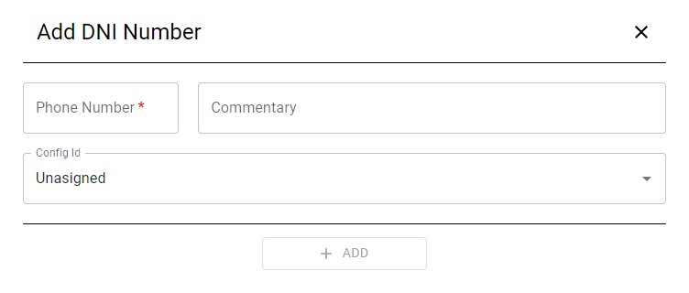

Services/Services
Add, update or edit redroof-ivr-serviceconfig database. This maps queues to whisper prompts.
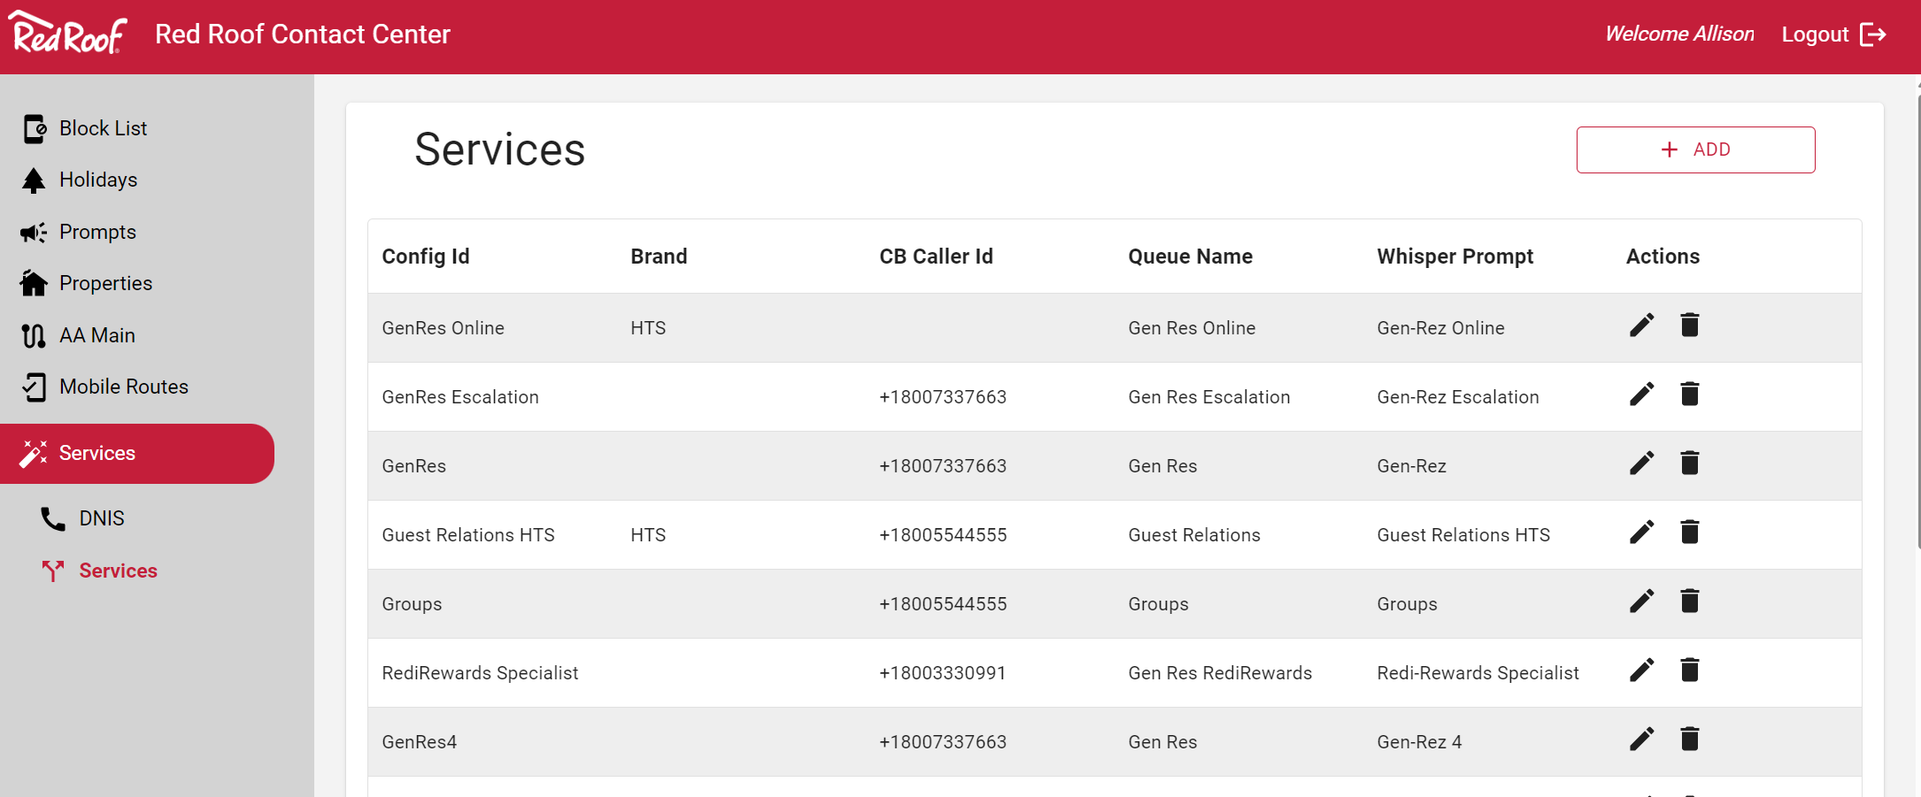

Thank you

Contact:
Allison Bicker, CX Business Analyst
allison.bicker@softwareone.com
Scott Taylor, CX Specialist
scott.taylor@softwareone.com

Disclaimer
This publication contains confidential and proprietary information that is protected by copyright. SoftwareOne reserves all rights thereto. SoftwareOne shall not be liable for obvious typing and arithmetic errors in any document provided by SoftwareOne. Liability for damages directly and indirectly associated with the supply or use of this document is limited in accordance with the supply or use of this document is excluded as far as legally permissible.
The SoftwareOne Services Statement of Work presented herein is intended exclusively as a guide to enable Red Roof Inn's representatives to evaluate the offering of SoftwareOne. It must not be copied, reproduced, passed to third parties or used for engineering purposes without the express permission of SoftwareOne.
Copyright © 2023 by SoftwareOne. All rights reserved. SoftwareOne is a registered trademark of SoftwareOne AG. All other trademarks, service marks or trade names appearing herein are the property of their respective owners.



